Contents

UNIT 1: Networking, INTERNET, OSI and TCP model 2

NETWORKING 2

Computer Network: 2

The Internet 2

INTERNET SERVICE 3

The Intranet 3

Network Topology: 3

TYPES OF NETWORK: 4

LAN (Local Area Networking) 4

MAN (Metropolitan Area Networks) 5

WAN (Wide Area Networks) 5

CAN (Campus Area Networks) 6

SAN (Storage Area Network) 6

OSI REFERENCE MODEL: 7

FUNCTIONS OF PHYSICAL LAYER: 7

FUNCTIONS OF DATA LINK LAYER: 7

NETWORK LAYER 8

Functions of network layer: 8

TRANSPORT LAYER - OSI MODEL 8

Session Layer - OSI Model 9

FUNCTIONS OF PRESENTATION LAYER: 9

OVERVIEW OF TCP/IP MODEL: 10

TCP/IP Protocol Architecture Model 10

# UNIT 1: Networking, INTERNET, OSI and TCP model

## NETWORKING

Networking is the connection established between several devices to enable them to communicate and share resources among each other.

## Computer Network:

It is a collection of hardware and software that enables group of devices to communicate and share resources such as data, files, programs, memory and so on.

## The Internet

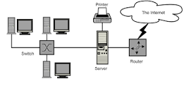

The public Internet is a world-wide computer network, i.e., a network that interconnects millions of computing devices throughout the world.

Node: Each device on a network is called as a node.

Media or communication link:the actual path via which data travels from one node to another. This path can be

Physical (cable)

Wireless (infrared signals)

Protocol: Set of rules to be followed by communicating devices in a network. TCP (the Transmission Control Protocol) and IP (the Internet Protocol) are two of the most important protocols in the Internet.

Protocol suite: is a set of related protocols.

Router/Switch: are the devices in a network that directs the movement of data from node to node until it reaches to the destination node.

Server: provider of services to various systems in a network or internet.

link bandwidth : The link transmission rate measured in bits/second.

packet switching: the Internet uses a technique that allows multiple communicating end systems to share a path, or parts of a path, at the same time.

## INTERNET SERVICE

The Internet provides two services to its distributed applications: *a connection-oriented service* and a *connectionless service*.

Connection-oriented service guarantees that data transmitted from a sender to a receiver will eventually be delivered to the receiver in-order and in its entirety.

Connectionless service does not make any guarantees about eventual delivery

## The Intranet

These private networks are often referred to as intranets. They exists within a building or organization and is accessible only by a limited number of people.

## Network Topology:

Defines the shape and structure of a network.

Different types of network topology are

Bus topology

Star topology

Ring topology

Mesh topology

## TYPES OF NETWORK:

There are 3 main network types

LAN (local area Network)

MAN (metropolitan Area network)

WAN (Wide Area Network)

## LAN (Local Area Networking)

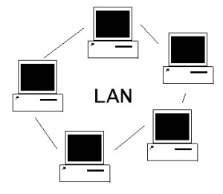

Local Area Networking

It is a private network owned by someone.

LAN is used in small areas such as schools, office or any building.

Due to its small size, single person can administrate the network.(centralized administration).

Local Area Networks are viable to quick change, using a [bus network topology](http://networkwire.org/network-topology.html) that allows for easy access to the Local Area Network.

## MAN (Metropolitan Area Networks)

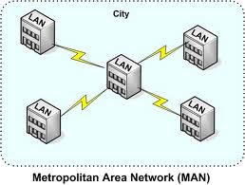

Metropolitan Area Networks

MAN is used to provide communication systems in an entire city.

Its size falls between LAN and WAN.

More administrators are required to administrate such network.(decentralized administration used).

Network complexity is more than LAN but less than WAN.

## WAN (Wide Area Networks)

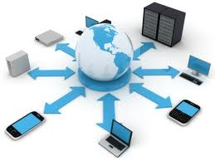

Wide Area Networks

Wide Area Networks are used to connect server machines and computers across continents and countries for constant information updates.

Networks across the globe are connected to create one giant network.

One such example is The Internet.

Since its size is wide, network complexity is more .

A great many administrators are required to administrate such network.(Decentralized administration is done).

## CAN (Campus Area Networks)

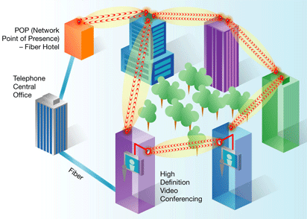

Campus Area Networks

Campus Area Networks are usually a connection of many small LAN networks which are often used on university campuses and office buildings. Campus Area Networks allow for easy file sharing between different departments.

## SAN (Storage Area Network)

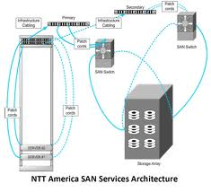

Storage Area Network

Storage Area Networks are primarily used as information databases. They are specifically used for the storage of information, and easy retrieval of specific pieces of data whenever required

# OSI REFERENCE MODEL:

Application

**All**

Presentation

**people**

Session

**seems**

Transport

**to**

Network

**need**

Data link

**data**

Physical

**packet**

## FUNCTIONS OF PHYSICAL LAYER:

**Representation of Bits:** Data in this layer consists of stream of bits.

**Data Rate:**This layer defines the rate of transmission which is the number of bits per second.

**Transmission Modes:**Physical Layer defines the direction of transmission between two devices: Simplex, Half Duplex, Full Duplex.

## FUNCTIONS OF DATA LINK LAYER:

**Framing:** Converts stream of bits into manageable data units called frames.

**Physical Addressing:**The Data Link layer adds a header to the frame in order to define physical address of the sender or receiver of the frame.

**Flow Control:**A flow control mechanism to avoid traffic.

**Error Control:** Data Link Layers adds mechanism to prevent duplication of frames.

## NETWORK LAYER

The main aim of this layer is to deliver packets from source to destination across multiple links (networks).

## Functions of network layer:

It translates logical network address into physical address.

Routers and gateways operate in the network layer.

Breaks larger packets into small packets.

Convert frames into IP packets.

## TRANSPORT LAYER - OSI MODEL

The main aim of transport layer is to be delivered the entire message from source to destination.

**Functions of transport layer:**

**Segmentation and Reassembling:**A message is divided into segments; transmitted and then reassembled at the destination end.

**Connection Control :**It includes 2 types :

Connectionless Transport Layer: Each segment is considered as an independent packet and delivered to the transport layer at the destination machine.

Connection Oriented Transport Layer: Before delivering packets, connection is made with transport layer at the destination machine.

**Flow Control:**In this layer, flow control is performed end to end.

**Error Control :**Error Control is performed end to end in this layer to ensure that the complete message arrives at the receiving transport layer without any error

## Session Layer - OSI Model

Its main aim is to establish, maintain and synchronize the interaction between communicating systems or applications.

**FUNCTIONS OF SESSION LAYER:**

**Dialog Control:**This layer allows two systems to start communication with each other in half-duplex or full-duplex.

**Synchronization:**This layer allows a process to add checkpoints which are considered as synchronization points into stream of data. Example: If a system is sending a file of 800 pages, adding checkpoints after every 50 pages is recommended. This ensures that 50 page unit is successfully received and acknowledged. This is beneficial at the time of crash as if a crash happens at page number 110; there is no need to retransmit 1 to100 pages.

## FUNCTIONS OF PRESENTATION LAYER:

Translation: Translates data into stream of bits.

Encryption: It carries out encryption at the transmitter and decryption at the receiver.

Compression: It carries out data compression to reduce the bandwidth of the data to be transmitted.

## OVERVIEW OF TCP/IP MODEL:

### TCP/IP Protocol Architecture Model

The OSI model describes an idealized network communications protocol family. TCP/IP does not correspond to this model directly, as it either combines several OSI layers into a single layer, or does not use certain layers at all. The following table shows the layers of the Solaris implementation of TCP/IP, listed from topmost layer (application) to lowest (physical network).

Table 4-2 TCP/IP Protocol Stack

| **OSI Ref. Layer No.** | **OSI Layer Equivalent** | **TCP/IP Layer** | **TCP/IP Protocol Examples** |
| --- | --- | --- | --- |
| 5,6,7 | Application, Session, Presentation | Application | NFS, NIS+, DNS, telnet, ftp, rlogin, rsh, rcp, RIP, RDISC, SNMP, and others |
| 4 | Transport | Transport | TCP, UDP |
| 3 | Network | Internet | IP, ARP, ICMP |
| 2 | Data Link | Data Link | PPP, IEEE 802.2 |
| 1 | Physical | Physical Network | Ethernet (IEEE 802.3) Token Ring, RS-232, others |

**Physical Network Layer**

The physical network layer specifies the characteristics of the hardware to be used for the network.

**Data-Link Layer**

The data-link layer identifies the network protocol type of the packet, in this case TCP/IP. It also provides error control and "framing."

**Internet Layer**

This layer, also known as the network layer, accepts and delivers packets for the network. It includes the powerful Internet protocol (IP), the Address Resolution Protocol (ARP) protocol, and the Internet Control Message Protocol (ICMP) protocol.

IP Protocol

The IP protocol and its associated routing protocols are possibly the most significant of the entire TCP/IP suite. IP is responsible for:

**IP addressing** 

**Host-to-host communications**

**Packet formatting**

**Fragmentation** –

ARP Protocol

. ARP assists IP in directing datagrams to the appropriate receiving host by mapping Ethernet addresses (48 bits long) to known IP addresses (32 bits long).

**ICMP Protocol**

Internet Control Message Protocol (ICMP) is the protocol responsible for detecting network error conditions and reporting on them.

**Transport Layer**

The TCP/IP transport layer protocols ensure that packets arrive in sequence and without error, by swapping acknowledgments of data reception, and retransmitting lost packets.

TCP Protocol

TCP enables Connection oriented data transmission service.

UDP Protocol

UDP, the other transport layer protocol, It provides connectionless data transmission service.

**Application Layer**

The application layer defines standard Internet services and network applications that anyone can use. These services work with the transport layer to send and receive data. There are many applications layer protocols, some of which you probably already use. Some of the protocols include: FTP, Telnet, SMTP, HTTP and so on.